Thinking About Research

What Is Research?
Research is the process we undertake when:
- We have a question to answer (the research question)
- We need to acquire knowledge (the research process)
- We want to extend our understanding of the world (the research outcome)

Key terms defined
Theory: Ideas or concepts that can be used to explain and understand an event, situation, or phenomenon. This can operate at three levels:
Macro – grand theories that cover broad aspects of the social world
Meso – mid‑level theories relating to organisations, families, communities, etc.
Micro – local or small‑scale theories
Concept: An abstract idea that describes or encapsulates a phenomenon.
Paradigm: A clustering of ontological, epistemological and a theoretical position.
Hypothesis ; A testable assertion about the relationship between things.
What Makes Good Research?
Good research is characterised by the following qualities:
- Structure and Purpose
Provides knowledge that is useful and meaningful
- Rigour
Research is carefully planned and systematically conducted
- Robust and Defensible (Quality)
  - Validity and Credibility
Am I researching the correct phenomenon? Is the data relevant and appropriate for the research question?
  - Generalisability and Transferability
To what extent can the findings be applied beyond the study? In which contexts are the conclusions valid?
- Systematic
The research follows a logical and organised process

Steps of the Research Process
Step 1: Research paradigm
There are four things to be considered in this:
- Domain: What is the domain? What constitutes subject matter?
- Reflexivity – how do I relate to the world and the subject matter?
- Ontology (what exists) – objects, properties, events, processes, relations etc.
There are many different ontological positions. Here are three
- Objectivism: Social phenomena has existed for their own sake, apart from and independent to the social actors.
- Constructivism: Social phenomena are real in the sense that they are constructed ideas that are being reviewed and reworked by those involved in them. However, the meanings and the understanding is open to study. The researcher themselves bring their own meanings to the study.
- Realism: Like the positivist but argues there is a part of the social reality that cannot be directly observed since its hidden.
- Epistemology – How do we come to know?
- Positivism- Stems from the objectivist position. There is a social reality to be studied that is independent from the researcher and the research subjects. This type of research includes quantitative data to be collected, reality is measured, causal relationships are sought.
- Interpretivism-Connected to the idea of Constructivism. Nature of the social phenomena is studied relative to the subjects. This prioritises people’s subjective interpretations. Knowledge of meanings and understandings and meanings are considered. Enabling of different perspectives to be explored. Usually qualitatively rich, meanings and understandings to be considered.
- Realism-Reality exists outside of the researcher, and this can be studied objectively like natural sciences. But the social reality is underpinned by invisible but powerful structures or mechanisms. Therefore, the main goal of the realist is to identify the hidden mechanisms and the observable effects. Could collect quantitative or qualitative data, uncover power relations, and research that leads to action.
Step 2: Research Questions
Step 2.1 Understanding the type of research question:
There are four types of research questions:
- Descriptive research: Focuses on describing characteristics, patterns, or phenomena as they exist, without investigating causes.
- Exploratory research: Conducted when little is known about a topic; aims to explore, identify patterns, and generate initial insights or hypotheses.
- Explanatory research: Seeks to explain why something happens, mainly through identifying and analysing causal relationships.
- Evaluation research: Assesses the effectiveness, impact, or value of a program, policy, intervention, or process.
Some research questions may combine elements of more than one type.
The research question leads to hypothesis. Hypotheses are mainly used to look at relationships between concepts that are statistically testable. In other words, it can identify and measure key elements, data is gathered and tested using statistical theory. There are two main relationships that are tested in this manner.
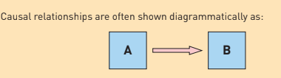
- Causal relationships: A causes B

- Associative relationships: A and B are related. But not sure how. The association could take many forms:


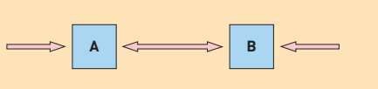
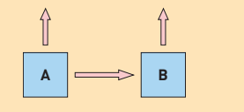
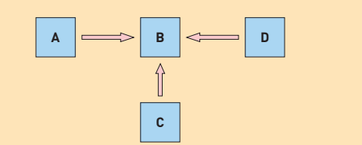

Step 2.2 Understanding the operational definitions
Take your research question define key concepts. Makre sure to understand what each word means and is consistent with all testing. This is so that the meanings are conveyed correctly and that you get the same type of answers. Can also use other people’s definitions. Should also pilot test the definitions.
Step 2.3 Developing the research question.
Initially he question could be at a high level, As your operational definitions have been developed, there may be more subsidiary questions that need to be answered. These questions help you to specify the exact are that you will focus on.
Step 3: Mitigating considerations (Data and Ethics)
3.1 The role of data:
We cannot simply know social phenomena. Therefore, data is used as a proxy to infer what happens to social phenomena. There are a few things to consider with data:
- There are various forms of data:
- Spoken and written text
- Non-verbal communication
- Factual data- through observation or through the knowledge of the owner.
- Value statements - Indications of opinions from their own judgement or criteria.
- One should also think about how the data is structured (Chronologically, focus on specific parts, could start with context setting)
- Data itself constructed by individuals or through entities. Therefore, one needs to think about what the data contents are and then what it means.
- Primary data created by the individual) and secondary data (Produced by others) have different strengths and weaknesses.
- Data and approaches:
Positivist ----->Factual and Value ------> Quantitative Methods
Interpretivist ----->Language + Spoken, Written & Nonverbal------> Qualitative Methods
*Increasingly there is the adoption of mixed methods approaches.

3.2 The role of Ethics:
Ethics: Social and moral values involved in undertaking social research.
Things to consider:
- Ethics approvals?
- Informed Consent
  - Consent should be freely given, information, risks, Informed consent.
- Power relationships
- Protection from harm
  - Physical, psychological, Other consequences, Risk, confidentiality, Honesty, anonymity, Data Protection. Cultural considerations.
- Key is for protection from harm.

Step 4: Planning the research Project
There are two groups of questions to be asked when planning your project:
- Questions related to the research project:
  - What is the purpose of the research?
  - What research has already been done?
  - How will you think to collect/ analyse/ present findings
  - What do you think the outcome of the work is ?
- Practicalities:
  - Alone or part of a team?
  - Timetable?
  - How will you measure progress?

Step 5: Literature review
Step 5.1: What is a literature review?
A literature review involves:
- Background reading – around the topic to see what has already been done.
- Search reading - compiling a list of sources and information
- Read and evaluate what you have found
- Structure and produce the review.

Step 5.2: Why is it necessary?
- Find out what is already known
- See all the different approaches
- Compare different opinions
- Lean the vocabulary
- Find the important issues
Step 5.3: What constitutes literature?
- Books
- Journals
- Media
- ‘Grey’ literature – produced for and by companies
- Official documents
- Search engines
Step 5.4: What is critical analysis?
Critical analysis is to ask how, why, and whether it holds up
- Why did you write this? ------>>> Why am I reading this?
- Who did you write it for? ------>>>- Was it written for “me”?
- What was your purpose? ------>>>What am I looking for?
- What questions were you asking? ------>>>What questions am I asking?
- What answers did you find? ------>>>- Do I find the answers credible
- What is your evidence? ------>>>Do I accept the evidence?
- What is your conclusion? ------>>>- Do I agree with the conclusions?
- Are the aims and objectives of the research clear?
- Do the authors explain their hypotheses, research questions, and underlying theories? (A2, A4)
- Is it clear who paid for the research (i.e., is there a possibility of a conflict of interests)?
- Are research questions and operational definitions plainly stated? (A4)
- Are the methodology and methods clear and appropriate? This will probably also include:
- a discussion of ethical issues (A5)
- an explanation of why the research was designed this way (B3)
- explanation and discussion of data collection methods and analytical processes (for example, whether a pilot study was carried out, the appropriateness of any statistical analyses)
- definitions of variables (if appropriate)
- sample design and sampling processes (B5)
- discussion of research instruments (for example, questionnaires, interview schedules, etc.) and their development
- Are the limitations of the methods used discussed?
- Are the results understandable and well discussed?
- Is the conclusion clear?
- Is there a discussion of whether the conclusion(s) can be generalised (i.e., applied to the whole population rather than just the sample)?
- Are there links between the conclusion(s) and the theoretical perspective?
- Is there a discussion of the implications of the conclusion(s)? (For example, is there a need to change policy because of what was found?)

5.5: Searching for literature
- Search for keywords
  - Can think of a spider diagram to think about all the areas that need to be explored.
- Think about types of sources
- How you will search
5.6: Reading the literature
Before you start reading:
- Look quickly through the book or paper, noting how it is structured and how headings are used.
- Read any introductions, abstracts, or contents pages.
- Use an index – if there is one – to point you to sections that are likely to be of interest.
- Ask yourself: Why am I reading this?
- Decide which sections or chapters you will read.

Then:
- Do a quick read, looking at the beginning of each paragraph to get a sense of how the section or chapter develops.
- Check again: Is this going to be useful to me?
- With your research topic in mind, read the section or chapter carefully, only making notes that relate to your research.
- Note down the page numbers of any key points or quotations you may wish to use, and sections you may want to return to for further study.
- Note down the full reference of the source.

Step 6: Research Design
Design is the skeleton. Strategy is the brain. Methods are the hands
Step 6.1 How can you use data
You can use data for social research in two ways:
- Look for similarities and differences
- Look for relationships
Step 6.2 Four types of research designs (How data is structured in time and space)
- Experimental research design:
  - Material cases can be manipulated by the researcher to make comparisons and measure differences.
  - Usually have an experimental group and a control group. RCTs are a good example.
- Cross sectional studies:
  - Units at a particular point in time.
- Longitudinal studies:
  - Across a period usually for multiple entities.
- Case studies
  - Single case or small number of cases where it is observed in depth.
  - Types: Critical case, Extreme or unique case, representative or the typical case, Revelatory case.
Step 6.3 Research Strategies (How data is collected and interpreted)
- Comparative research strategy: Make comparisons between entities
- Evaluation: Assess the value of something relative to a set of criteria.
- Ethnography: Data collected through immersion
- Grounded theory: Collects data then theorise.
Step 6.4 Research Methods
Methods should be determined by the questions.
Features of Qualitative or Quantitative Methods.
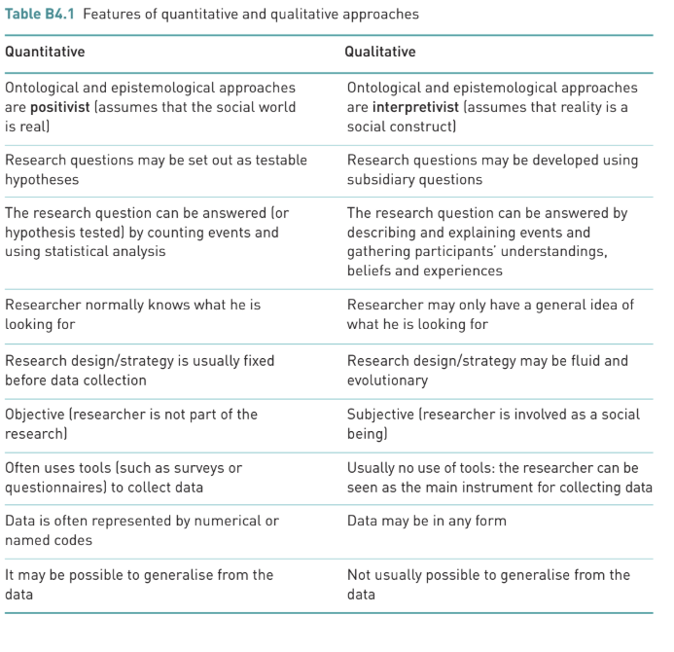
Ways of combining them:
  - Choose a mixed methods approach
    - Good for triangulation where one uses different types of data to address the same questions.
  - Qualitative can be used before Quantitive Methods.
  - Qualitative methods can be used after to identify interesting characteristics.

